最優秀 LOM 個人能力開発プログラム
Best Local Personal Skill Development Program
LOM名 |  | 申請担当者名
山形青年会議所 |  | JCI Yamagata
基本情報 |  | Basic Information
事業名 |  | Name
高瀬にべにっこ大集合！～郷土文化を次世代に継承～ |  | Safflower Dyeing in Takase – Conveying Regional Culture to the Next Generation
目的 |  | Purpose
・生活が物質的に豊かになり、精神的な豊かさも大切なことが  忘れられているように感じます  ・併せて都会がもてはやされ、生まれた地方の良さは見落とされがちです  ・そのため、本事業は以下を主な目的としました  ・次世代を担う子供たちが地域伝統や文化魅力と、人と人との繋がりの大切さを実感し、郷土を愛するこころを持った人財となること、  ・地域伝統や文化を再認識するとともに、郷土を愛するこころを持った人財になること |  | While our lives have grown richer in a material sense, we seem to have forgotten the importance of emotional enrichment. In addition, we may have a tendency to focus too much attention on the big cities, and overlook what is special about the region where we were born and raised. With this in mind, our project focused on the following objectives:  - To help the children who will become our future leaders learn about the special traditions and culture of their region, understand the importance of developing relationships with other people, and become members of society who love and appreciate their local region.  - To ourselves look with new eyes upon the traditions and culture of the region we call home, and to become individuals with a greater capacity to love and appreciate our local region.
開始日※日付で記載 |  | Start date
２０１７年１１月２４日 |  | JCIウェブフォームは、カレンダーから選択方式なので記載不要
終了日※日付で記載 |  | End date
２０１８年７月２４日 |  | JCIウェブフォームは、カレンダーから選択方式なので記載不要
事業対象者 |  | Target
・山形市内小学生以下の児童および保護者  ・山形市内商工会議所メンバー |  | - Preschool and elementary school students in the Yamagata city area, along with the parents of these students  - JCI Yamagata members
SDGsの該当項目  該当項目を１つのみ選択 |  | Sd goal
4質の高い教育をみんなに |  | Goal 4: Quality education
発展段階  Active Citizen Framework「展開」の項目での３項目の発展段階から選択 ①健康な身体と精神 ②教育と経済力強化 ③平和・繁栄・持続可能性 |  | Development stage  “Health and Wellness”・“Education and Economic Empowerment”・“Peace, Prosperity, and Sustainability”から選択
②教育と経済力強化 |  | Education and Economic Empowerment
概要 |  | Overview
子どもたちや保護者に以下の場を提供する  ・山形県花である紅花について学ぶ  ・ハンカチを用いて伝統的な紅花染めを実践  ・紅花染めハンカチを用いて鯉ぼりを作成、川辺に飾る  ・並行して紅花を使用した郷土料理試食を試食、学ぶ  ・木工品や紅花若葉、加工品や歴史などを盛り込んだ展示した  ブースにより実際に触って学ぶ  以上により、  ・紅花をはじめとした地域伝統や文化魅力について体験を通じて  学ぶことにより、愛郷心を持った魅力ある子供を育成する。  ・なお実施は旧暦で子供の日となる５月下旬であり、参加した子ども  たちの健やかな成長を皆で祈ります |  | In this project, we provided children and their parents with the opportunity to:  - learn about the safflower, Yamagata’s prefectural flower  - use traditional safflower dyeing techniques to hand-dye handkerchiefs  - make “koinobori” carp streamers with these handkerchiefs, and display the carp streamers along a riverbank  - taste and learn about regional dishes made with safflower  - visit booths displaying wood crafts, the young leaves of safflower plants, processed goods and other items where they could view and touch these items and learn about their history  By helping children learn about the special traditions and culture of their region through this hands-on experience centering around safflowers, we helped to nurture their love and appreciation for their local region. We held this event in late May, the date of Children’s Day according to the old lunar calendar, thereby symbolizing our wishes for the strong and healthy growth of the participating children.
- 目的・財務計画・実施 |  |  | Objectives, Planning, Finance and Execution
このプログラムの目的を記述してください。 |  |  | What were the objectives of this program? ※200単語まで
・普段できない伝統技能を実体験したり、地域の宝である伝統工芸品に触れたり、また講師より学んだりすることで、次世代を担う子供たちが地域伝統や文化魅力と、郷土を愛するこころを持った人財となること  ・地域伝統や文化を再認識するとともに、郷土を愛するこころを持った人財になること  ・共同作業を通じ人と人との繋がりの大切さを実感すること |  |  | - By giving children a hands-on opportunity to learn traditional techniques they would not normally encounter in their daily lives, and by enabling them to see and touch the traditional crafts treasured in their community while learning about these traditions from instructors, we sought to foster a love and appreciation for the local region in the children who will grow into our future leaders.  - We sought to ourselves look with new eyes upon the traditions and culture of the region we call home, and to become individuals with a greater capacity to love and appreciate our local region.  - Through group work, we also hoped to help participants understand the importance of developing relationships with other people.
このプログラムが、どのようにJCI行動計画に準じているかを記述してください JCI Plan of Actionを参照して、インパクトImpact（影響力）・モチベートMotivate（意欲）・インベストInvest（投資）・コラボレートCollaborate（協働）・コネクトConnect（つながり）についてそれぞれ記載してください |  |  | How does this program align to the JCI Plan of Action? ※200単語まで
IMPACT：子どもたちやその親と活動を行い、その指針や今後の行動に愛郷心という影響を与えた  Motivate：子どもたちやその親と共同作業を行い、皆で行動し物事を達成する楽しさを実感した  INVEST：マスメディア（新聞社）を呼び、活動の認知度を上げアピールした  COLLABORATE：JCメンバーはもちろんのこと、紅花染め協会の先生やふるさとの川愛護団体、地元自治会のほか、山形市長や山形市のマスコット『べにちゃん』と協力して推進した  Connect:子どもたちとその親、JCメンバーの共同作業で一体感を醸成した |  |  | Impact: By conducting an event with children and their parents which promoted their love and appreciation for the local region, we impacted their way of thinking and future actions.  Motivate: The group work we carried out with the children and their parents allowed them to experience the satisfaction of accomplishing things by working together.  Invest: We invited members of the media (newspapers) to cover the event, helping to raise awareness of and interest in our efforts.  Collaborate: JCI Yamagata carried out this project with the cooperation of members of a safflower-dyeing association, a local river conservation group, citizens’ groups, the mayor of Yamagata city, and the safflower-themed “Beni-chan” mascot character.  Connect: We established a sense of unified purpose through group work that involved the participation of children, their parents and JCI Yamagata members.
予算計画通りにプロジェクトを実行できましたか？  予算上の工夫や、予算の内訳の概算を記述してください |  |  | Was the budget an effective guide for the financial management of the project? ※150単語まで
予算総額 \800,000  決算総額 \789,003  内訳  ・企画演出費 \492,196  ・講師関係費 \26,727  ・広報費 \265,680  ・通信費 \4,400  ・雑費 \600  - 公共の施設や支援団体を活用することで費用を圧縮できた |  |  | Total budget: 800,000 JPY  Amount used: 789,003 JPY  (Breakdown)  Planning and implementation costs: 492,196 JPY  Instructor fees: 26,727 JPY  Publicity costs: 265,680 JPY  Communication costs: 4,400 JPY  Miscellaneous costs: 600 JPY  *We reduced expenses by utilizing public facilities and support groups
このプロジェクトはどのようにJCIミッション・ヴィジョンを推進しましたか？  ミッションとヴィジョンに分けて記載  ミッション：より良い変化をもたらす力を青年に与えるために、発展・成長の機会を提供すること  ヴィジョン：若き能動的市民の主導的なグローバル・ネットワークになること |  |  | How does this project advance the JCI Mission and Vision? ※200単語まで  【参考】  JCI Mission：To provide development opportunities that empower young people to create positive change  JCI Vision：To be the leading global network of young active citizens
JCI Missionの推進  ・子どもたちとともに地域伝統や文化魅力を学び、地元の良さに  ついて理解を深め、さらに愛郷心を強めました  JCI Visionの推進  ・愛郷心を強め、またさらなる未来を担う子どもたちと行動をした ことで、地元の将来や子どもたちの未来への関心を深めることができた |  |  | JCI Mission: We gained a greater understanding of the positive elements of our community and developed a greater love and appreciation for the local region by learning about its special traditions and culture.  JCI Vision: We invested a greater interest in the future of our community and our local children by strengthening our love and appreciation for the local region and engaging in a project with the children who will serve as our future leaders.
- メンバーの参加 |  | Membership Participation
LOMメンバーの事業参加人数を記述してください。（数字で記載） |  | By number, how many members were involved in this program? ※2単語まで
76名 |  | 76 members
LOMメンバーの参加率を記述してください（％で記載） |  | By percentage, how many members of the Local Organization were involved in this program? ※1単語まで
71％ |  | 71%
LOMメンバーの主な役割を記述してください。 |  | Describe the main roles of the participating members in this program. ※300単語まで
準備  ・講師、協力団体、市長打ち合わせ  ・チラシ配布、学校に宣伝協力依頼  当日  ・事業統括  ・参加者受付、応対、誘導  ・会場内警備  ・紅花染め補佐  ・紅花料理準備手伝い、配膳  ・駐車場警備  ・市長誘導 |  | Preparations:  - Conducting preliminary meetings with instructors, cooperating organizations, and the Yamagata city mayor  - Distributing flyers, asking schools to publicize and cooperate with our project  Day of event:  - Event supervision  - Welcoming and guiding participants  - Venue security  - Assisting with the safflower dyeing activity  - Helping to prepare safflower dishes, distributing food  - Keeping watch over the parking area  - Welcoming and accompanying the Yamagata city mayor
- 開発した能力 |  | Skills Developed
このプログラムによって、どのような能力を開発しましたか？ |  | What skills were developed in this program? ※150単語まで
・地元を巻き込みイベントを開催する発信力  ・イベントを滞りなく行う企画力  ・様々な人の協力を得る調整力、交渉力  ・子どもたちや親と共同作業する引率力  ・何より地元を大切に思う愛郷心 |  | - The ability to proactively involve the community in a JCI Yamagata-sponsored event  - The ability to plan and successfully carry out an event  - The ability to compromise and negotiate in a way that invited the cooperation of a wide range of people  - The ability to successfully lead children and their parents in a group activity  - The ability to love and appreciate the local region above all else
能力開発のために用いた手法や、行った活動を記述してください。 |  | How were these skills developed? Describe the methods and activities used. ※300単語まで
・参加者募集のため学校への広報活動  ・魅力的な宣伝ポスターの作成  ・自治会、婦人会への応援要請、折衝  ・マスコミの取材や市長来場への要請、折衝  ・イベントを滞りなく、効果的に行うための企画調整  ・鯉のぼり作成の共同作業 |  | - We visited schools to promote our event and recruit participants.  - We worked to create a poster that would attract attention and interest.  - We requested support from and conducted discussions with local citizens’ and women’s organizations.  - We asked members of the media to cover our event and negotiated the participation of the Yamagata city mayor in our activity.  - We developed and adjusted our plan so as to ensure that our event would be both successful and effective.  - We carried out a group activity centered around making “koinobori” carp streamers.
- 参加者への影響 |  | Impact on Participants
このプログラムによって与えたい参加者への影響を記述してください。 |  | What was the intended impact on the participants? ※150単語まで
・山形を代表する花である紅花について知識を深め、地域特産品について学びを深める  ・郷土を愛することできる人材育成に繋げる |  | By helping participants learn about the safflower, the Yamagata prefectural flower, this program sought to promote a greater understanding of the special products of the region.  This program also sought to nurture the development of individuals with the capacity to love and appreciate their region.
参加者への実際の影響を記述してください。 |  | Describe the actual impact on the participants. ※300単語まで
参加者アンケート回答者全員が以下の回答  ・紅花について知識を深めることができた･･･はい  ・一緒に取り組んだ仲間と鯉のぼりを楽しく作ることができた･･･はい  その他（フリー回答）  ・知らなかった文化に触れることができた  ・楽しかった 等  以上により、参加者の多くが、地域伝統や文化の魅力と、人と人との繋がりの大切さを感じていただけたと考える。 |  | In the questionnaire we conducted after the event, all participants gave affirmative answers to the following questions:  - Did you gain a better understanding of the safflower?  - Did you enjoy making “koinobori” carp streamers with the other participants?  In the questionnaires, participants also freely offered comments telling us that the event had helped them to come into contact with a part of their culture that they had not been aware of before, and that they truly enjoyed the activity.  Through these responses, we were able to conclude that the majority of participants were able to learn something about the special traditions and culture of their region, in addition to the importance of developing relationships with others.
- プログラムの長期的な影響 |  |  | Long-term Impact of the program
このプロジェクトによって得られると予測される長期的な影響を記述してください。 |  |  | What is the expected long-term impact of this project? ※200単語まで
・子どもたちやJCメンバー、その他参加者は地域の伝統や文化の魅力を学びました。また、愛郷心が高まり、今後地元を大切に思い、地元を意識した活動を行うと期待します  ・共同作業を行い、またその大切さ、楽しさを学びました。この経験を元に、今後主体的に、皆を巻き込んだ活動を行う、行える人物が増えることに期待します。 |  |  | The children, JCI members and other participants were provided with an opportunity to learn about the special traditions and culture of their region which strengthened their love and appreciation for the region in which they live, and we expect that this will motivate them to place more importance on their community and carry out efforts to benefit the community in the future.  Through our group activity, participants learned the importance of working together, and how enjoyable it can be. We expect that this experience will help to nurture individuals who have the capacity and inclination to carry out efforts involving other members of the community in the future.
このプロジェクトの改善点・改善策を記述してください。  ※マイナスな表現はしないでください。前向きな改善点を記載しましょう |  |  | What changes would you make to improve the results of this project? ※300単語まで
・スケジュールが一部小学校の運動会にかぶる等の悪条件があり、参加したくてもできない子どもや保護者もいた  ・毎年度継続して実施することで、今回参加できなかった子どもたちも参加して様々なことを学んでもらえるよう、同じイベントにこだわらず次はさらに有意義なイベントを開催したい |  |  | Our event coincided with Sports Day events at some elementary schools, and this and other scheduling conflicts made some interested children and parents unable to take part. We would like to conduct this program on an annual basis, allowing children who were unable to participate this time to take part and learn a variety of things in future events, and we will move beyond this year’s theme and carry out new events that focus on further ways of benefiting and educating children.

「目的・財務計画・実施」項目に添付する画像を下部に貼付してください
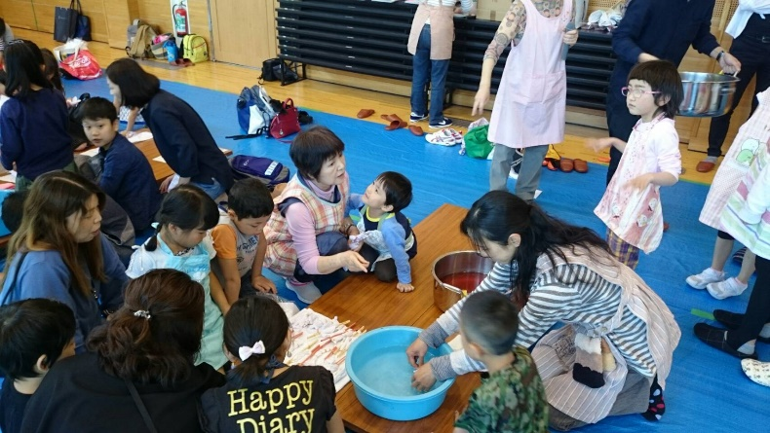 | 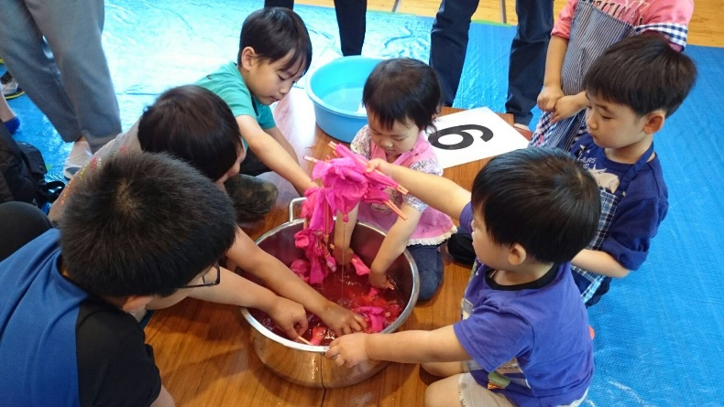
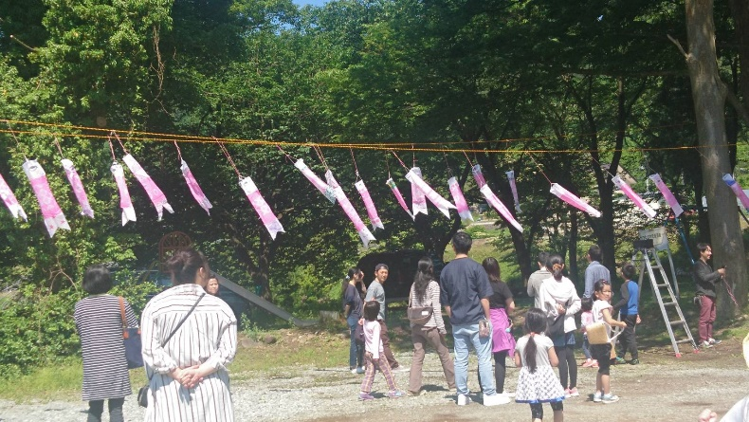 | 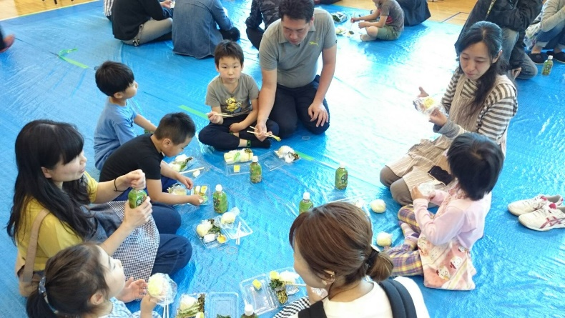

「メンバーの参加」項目に添付する画像を下部に貼付してください
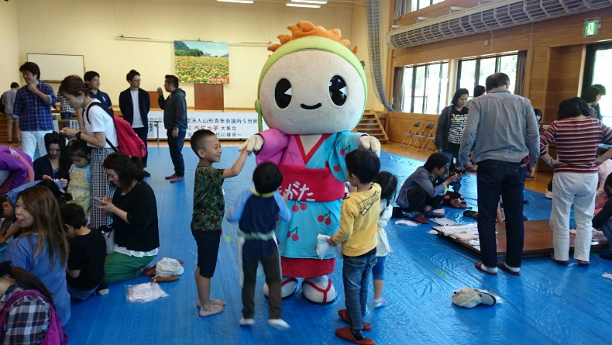 | 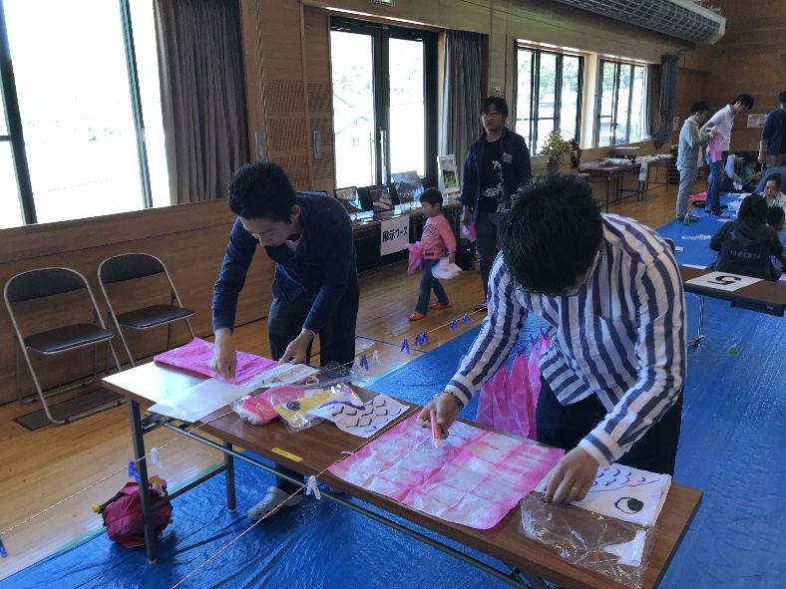
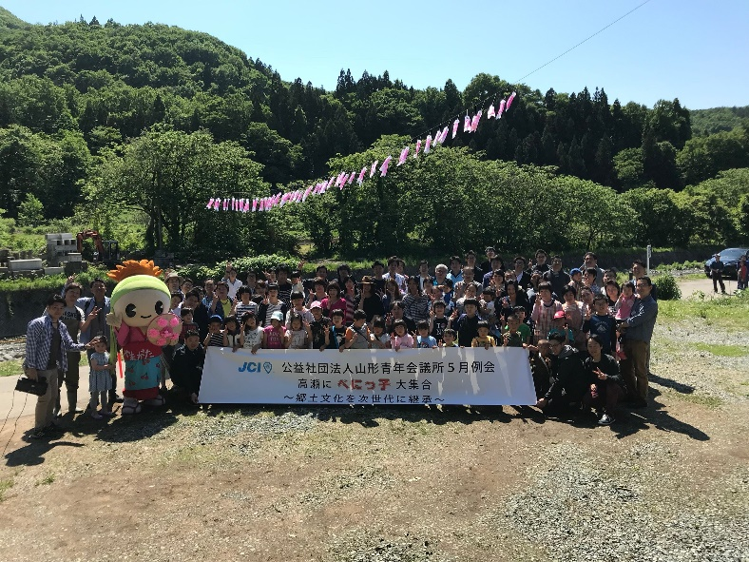

「開発した能力」項目に添付する画像を下部に貼付してください
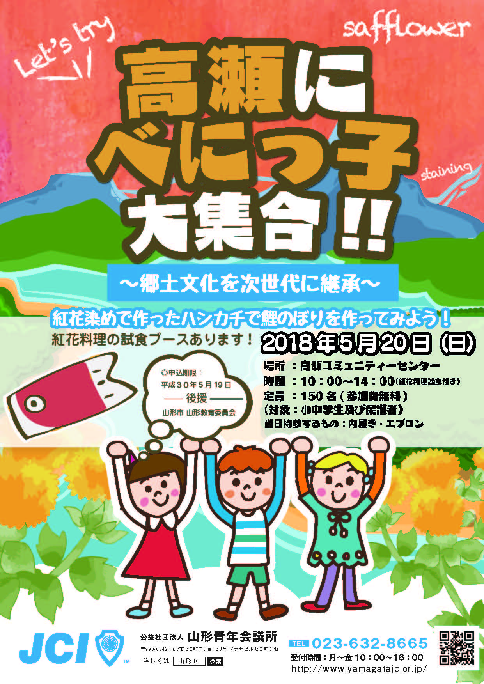 | 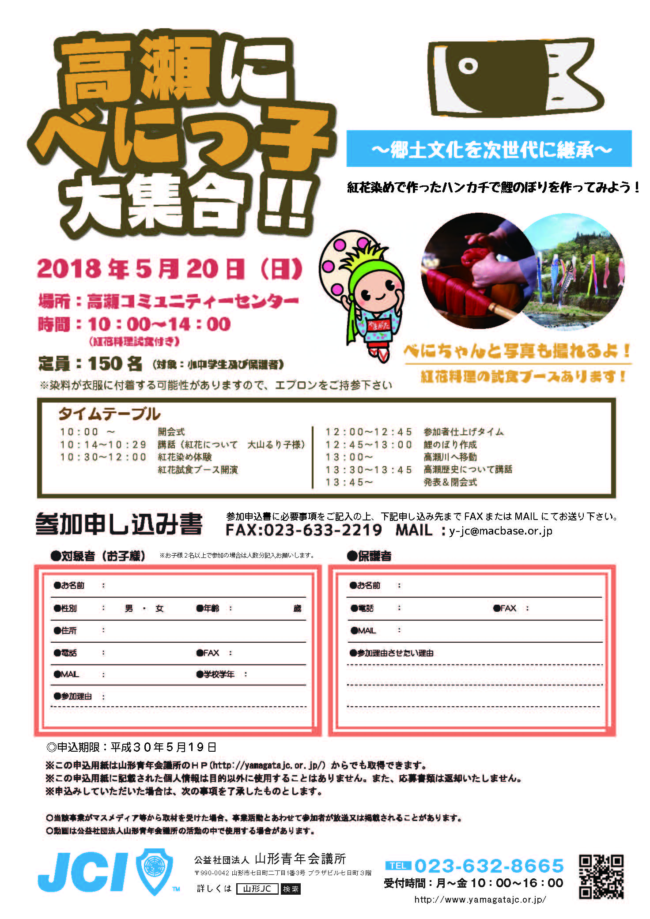

「参加者への影響」項目に添付する画像を下部に貼付してください
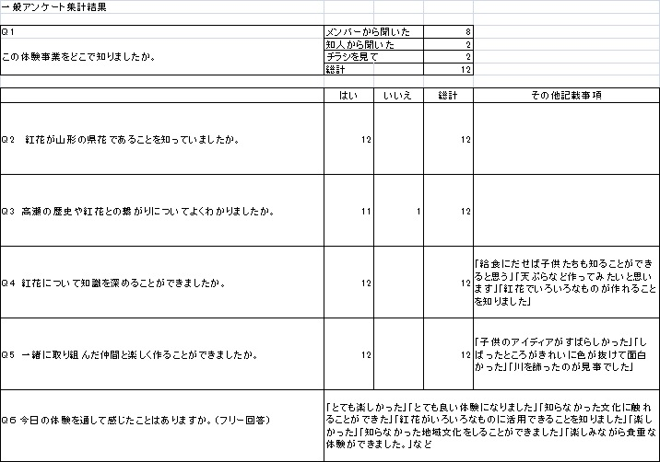 | 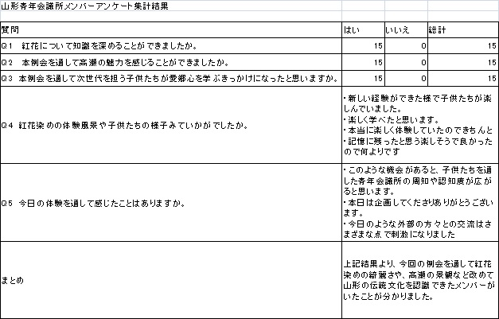

「プログラムの長期的な影響」項目に添付する画像を下部に貼付してください

